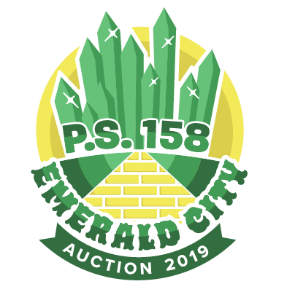
Sponsor The Emerald City and Join the Party!
There are two ways to sponsor the event:
Family Sponsorship OR Family Corporate Sponsorship. All sponsorships receive:
- Family Name showcased on the “Sponsors” wall in the small cafeteria
- Special thanks in our auction catalog and on our auction website
- Two (2) tickets to the Auction Benefit (value $130-170)

FAMILY Sponsorships:

$275+ Lion $225 Tin Man $185 Scarecrow

Lion Sponsors will have their family name displayed on the Auction bidding devices.
Scarecrow and Tin Man Sponsors will receive raffle opportunities.

FAMILY-CORPORATE Sponsorships: For PS 158 family-owned business

$1,500+
- Full-page advertisement and special thanks in Auction catalog.
- Interactive corporate logo displayed on the Auction bidding device.

$1,000
- Half-page advertisement and special thanks in Auction catalog.
- Interactive corporate logo displayed on the Auction bidding device.

$700
- Prominent logo placement seen by all auction attendees.
- Interactive corporate logo displayed on the Auction bidding device.

$250
- Logo placement on our customized event website.
- Interactive corporate logo displayed on the Auction bidding device.

Advertisement/logo must be submitted by Monday, March 4 to be included in the catalog. Please fill out the form and email a high-resolution ad or business card and logo (160 pixels by 80 pixels) to 158donations@gmail.com.

Auction Sponsorship

Sponsor’s Information

Name (First and Last):
Street Address:
City, State, Zip:
Contact Email:
Contact Phone: |  | Contact Fax:
Child’s Name |  | Child’s class:

Display Family Name exactly as:

Please select sponsorship type:

Family Sponsorship

$275 Lion
$225 Tin Man
$185 Scarecrow

Family-Corporate Sponsorship

$1,500+ Emerald City (Amount $________)
$1,000 Over the Rainbow
$700 Yellow Brick Road
$250 Munchkinland

MAKE CREDIT CARD PAYMENTS ONLINE: http://www.ps158.org/auction
PAYMENT ENCLOSED: Check* Cash
*Please make checks payable to PS 158 Parents’ Association.

Please return this form with your donation to the PA office, attention Paulina Levine or Jen Joseph. If you have any questions, please contact the PA at 158donations@gmail.com

